**Neville:**

To prove the correctness of the algorithm we used the wolframalpha software:

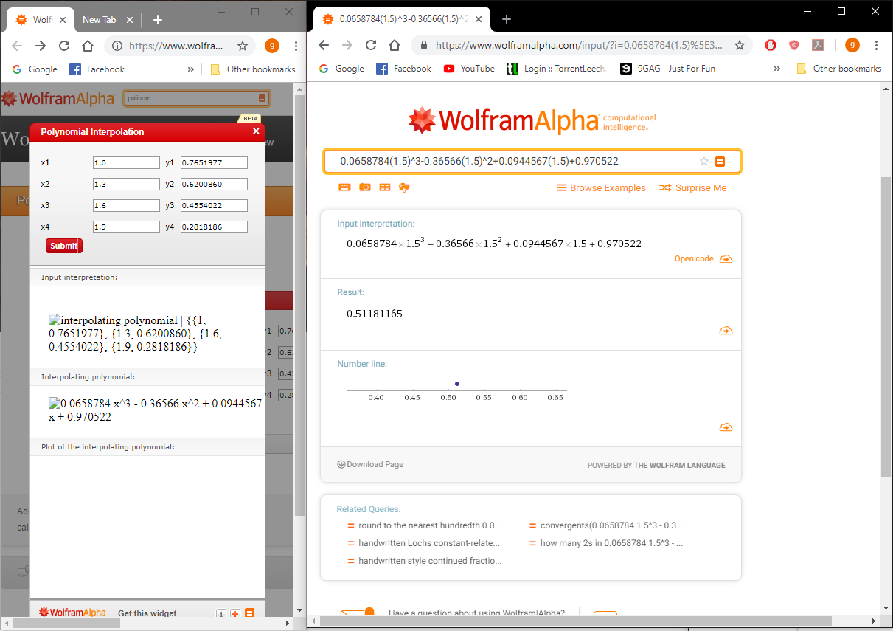

The algorithm in code and its results:

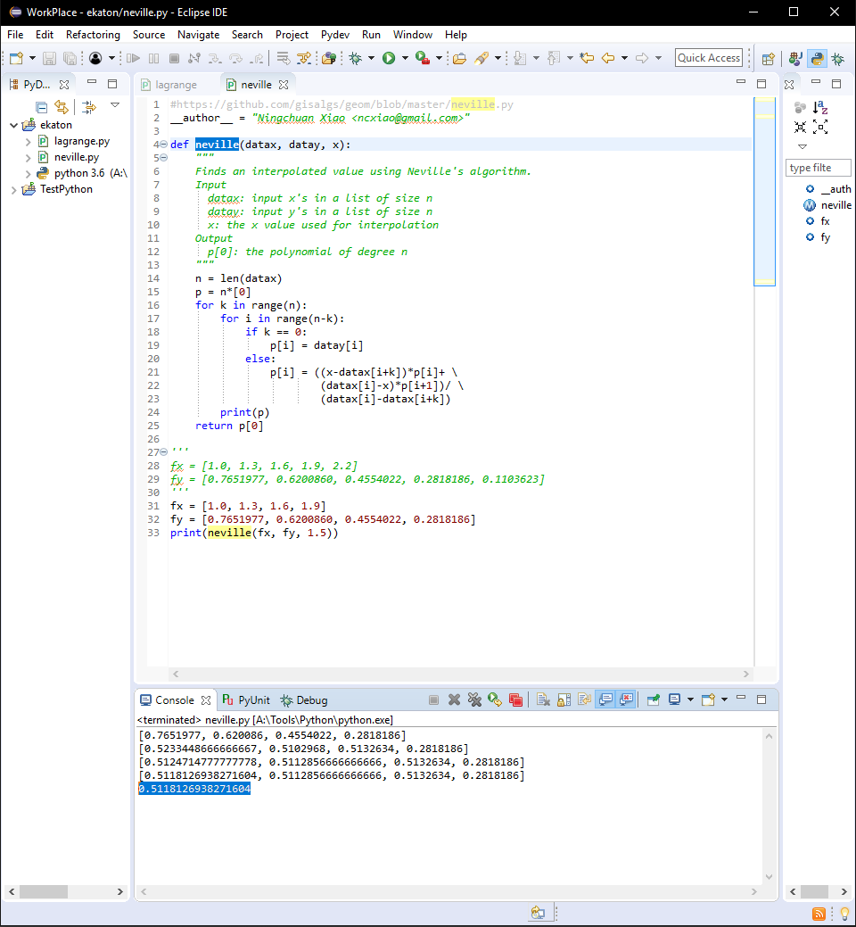

**Neville interpolate error:**

